Model Title Page

Title of the Dissertation
The Impact of Destination Marketing on Tourist Arrivals: A Case Study of VisitBritain

By:

Year of publication

Submitted in Partial Fulfillment of the Requirements for the Bachelor of Science BSc. degree.

Canterbury Christ Church University

Copyright Acknowledgement Form
Canterbury Christ Church University

I, the writer’s full name, understand that I am solely responsible for the content of this dissertation and its use of copyrighted materials. All copyright infringements and issues are solely the responsibly of myself as the author of this dissertation and not Canterbury Christ Church University, its programs, or libraries.

______________________________ _______________________
Signature of Author Date
Abstract

This study examined how destination marketing influences tourist arrivals in Britain, focusing specifically on the role of VisitBritain. The research investigated the destination marketing strategies adopted by VisitBritain, assessed the impact of these strategies on tourist numbers and considered the key obstacles and opportunities of destination marketing. The methodology used in this study was qualitative research with an interpretivist philosophy and an inductive approach. A case study approach was used for VisitBritain, and academic literature, tourism reports, government publications and relevant organisational sources were used to gather secondary data. Thematic analysis was used to look for patterns and findings in the collected information to address the research aims.
Three key areas were identified in the findings: Firstly, it was found that destination marketing using visual promotional content, strategic partnerships and digital technologies are important destination marketing strategies that can contribute to improving destination visibility and shaping positive perceptions. Second, marketing can also help to raise awareness, build interest among tourists and contribute to destination brand equity, but such effects will also be shaped by traveller interests and market conditions. Third, climate change, technological progress, greater competition and the application of artificial intelligence are challenges and opportunities in destination marketing. The study concluded that destination marketing efforts (integrated, targeted and adaptable) can help to attract tourists and improve the competitiveness of a tourism destination. VisitBritain needs to focus more on digital and visual promotion, build strategic partnerships, utilise new technologies, as appropriate, and put more emphasis on sustainability and visitor expectations.

Acknowledgments
I wish to express gratitude to everyone who supported me in the completion of this dissertation. I would like to express my gratitude most particularly to my supervisor for his guidance, valuable suggestions and constructive feedback throughout the research process. I also thank my university and academic staff for their support and encouragement which kept me focused at my work. I would like to express my gratitude to my family and friends for their patience, motivation and constant encouragement throughout the difficult times during this study. Finally, I would like to express my gratitude to all who contributed directly or indirectly toward the completion of this dissertation.

Dedication
I certify that this is my own work and that I have worked alone and with no plagiarism. Sources of research have been correctly cited and referenced. I hereby certify that the information does not contradict, to the best of my knowledge, and that academic integrity has been observed throughout.

Table of Contents
CHAPTER 1. INTRODUCTION 1
1.1 Introduction 1
1.2 Background and context 1
1.3 Problem Statement 2
1.4 Research Aim and Objectives 2
1.5 Research Questions 2
1.6 Significance of the Study 3
1.7 Dissertation structure 3
1.8 Chapter Summary 3
CHAPTER 2. LITERATURE REVIEW 5
2.1 Introduction to the Literature Review 5
2.2 Review of Related Key Concepts 5
2.3 Review of Relevant Theories 6
2.4 Empirical Review 7
2.5 Literature Gap 9
2.6 Chapter Summary 10
CHAPTER 3: RESEARCH METHODOLOGY 11
3.1 Introduction to Methodology 11
3.2 Methodological Framework: Application of Onion Model 11
3.2.1 Research Philosophy for the Dissertation 12
3.2.2 Research Approach for the Dissertation 12
3.2.3 Research Strategies/Design for the Dissertation 12
3.2.4 Choices for the Dissertation 13
3.2.5 Time Horizons for the Dissertation 14
3.3 Data Collection Techniques 14
3.4 Analytical Techniques and Procedures 15
3.5 Ethical Issues 15
3.6 Chapter Summary 15
CHAPTER 4: ANALYSIS AND DISCUSSION OF RESULTS 16
4.1 Introduction 16
4.2 Presentation of Results 16
4.3 Data Analysis/Results 19
4.4 Discussion of the Findings in Relation to Theoretical Framework 20
4.5 Chapter Summary 22
CHAPTER 5: CONCLUSIONS AND DISCUSSION 23
5.1 Introduction 23
5.2 Summary of Findings 23
5.3 Recommendations 23
5.4 Limitation of the Study 24
5.5 Suggested Areas for Future Research 24
5.6 Conclusion 25
REFERENCES 26
Appendix A – Reflective Statement 32
Appendix B – Evidence of Ethics Form Approval 33
Appendix C – Individual Digital Log 37
Appendix D – Data 38
Appendix E – Results 40

List of Tables
Table 1: Inclusion and Exclusion Criteria 13
Table 1 Thematic Coding Table 16
Table 3 Review of Selected Articles 38

List of Figures
Figure 1: Conceptual Framework 6
Figure 2: Saunders' Research Onion 11

CHAPTER 1. INTRODUCTION

1.1 Introduction
This chapter presents the study that was done on the effect of destination marketing on tourist arrivals, with VisitBritain as the case study. It gives the background and context of the study, research problem, and research aim, objectives and questions. The chapter also gives the importance of the study, the study structure, which is a dissertation and finally gives a summary to form the basis of the other chapters.

1.2 Background and context
As a tourist destination, destination marketing is very important to the national tourism organisations since tourism is a major employer, job creator and source of cultural exchange (Morrison, 2023). As the competitive tourist market around the world increases, destinations must ensure that they have a distinct brand name through a successful branding exercise, online marketing initiatives, strategic alliances and targeted marketing initiatives that would bring international tourists to the destination. The main aim of destination marketing is to make a good image of the place, enhance people's awareness about the place and influence the choice of tourists, ultimately helping in the greater arrival of tourists and the final outcome, which is the increase in tourism revenue.
VisitBritain, the national tourist authority of Great Britain, takes a leading role in marketing England, Scotland and Wales to the international market. VisitBritain aims to enhance the international tourism attraction of Britain using integrated marketing campaigns, social media, market research and partnerships with the travel trade partners (Khemraj, 2024). After negative events like the COVID-19 pandemic, varying tastes of travellers, and rising competition with other destinations, successful destination marketing is more vital now than ever. The analysis of VisitBritain offers a good understanding of how marketing strategies can be used to affect the behaviour of tourists, aid tourism recovery, and improve destination competitiveness. It is based on this context that the relationship that exists between destination marketing activities and tourist arrivals in Great Britain can be investigated.

1.3 Problem Statement
Destination marketing has gained more significance as countries fight to impress or entice more international tourists in a very competitive tourism market internationally. Despite the heavy investment that VisitBritain pays in branding, online marketing and promotion campaigns, it is not clear what role these promotional initiatives play in directly affecting tourist arrivals (Reinhold et.al. 2023). The success of marketing activities may be curtailed by external forces like economic uncertainty, consumer preference changes, international crises, and other competitors (Aripin et.al. 2024). Moreover, there is little research that has systematically investigated the connection between the destination marketing strategies of VisitBritain and tourist arrivals, taking into account the challenges and opportunities. Thus, this research paper aims to fill this gap through the assessment of the effectiveness of VisitBritain's destination marketing efforts and its role in tourist attraction and competitiveness of the tourism industry in Great Britain.

1.4 Research Aim and Objectives
Aim of the study:
The aim of this research is to investigate the impact of destination marketing on tourist arrivals, using VisitBritain as a case study.
Objectives:
- To examine the destination marketing strategies used by VisitBritain.
- To analyse the impact of VisitBritain's destination marketing on tourist arrivals.
- To identify the challenges and opportunities of destination marketing in attracting tourists through VisitBritain.

1.5 Research Questions
- What destination marketing strategies are used by VisitBritain?
- How does VisitBritain's destination marketing influence tourist arrivals?
- What are the main challenges and opportunities of destination marketing in attracting tourists through VisitBritain?

1.6 Significance of the Study
The importance of this study lies in its role towards a clearer comprehension of how destination marketing applies to tourist arrivals, especially the case of VisitBritain. The results will be useful in understanding the success of destination marketing activities, including branding, online promotion, and promotional campaigns, in attracting foreigners (Blanco-Moreno et.al. 2024). The study will be helpful to the tourism policymakers and destination marketing organisations because it will provide effective practices and identify where improvement is needed to maximise tourism competitiveness.
The tourism businesses like the travel agencies, hotels, and tour operators will also find the research helpful as it will enhance their knowledge about the role of the national marketing initiatives in visitor demand and travel behaviour. In addition, the study will be beneficial to the current academic literature on destination marketing as it will offer evidence based on the case of VisitBritain, thus making future tourism marketing and destination management studies valid (Gato et.al. 2022). Lastly, the results can guide decision-makers to come up with better and sustainable marketing promotions that address evolving tourist preferences and position Great Britain as a top global destination to touring locations.

1.7 Dissertation structure
There are five chapters in this dissertation. Chapter One addresses the topic of the research, which encompasses background, problem statement, aim, objectives, research questions, significance of study and dissertation structure. The second chapter presents the literature review, in which the topical theories and previous studies are presented on the topics of destination marketing and tourist arrivals. Chapter Three describes the research methodology which was utilised in the study. The analysis and discussion of the findings are given in Chapter Four. Lastly, Chapter Five contains the conclusions, recommendations, limitations and suggestions for future research.

1.8 Chapter Summary
The chapter presented the research by creating a background and context of destination marketing and its significance in affecting tourist arrivals using VisitBritain as the case study. It outlined the problem, research aim, research objectives, and research questions that will be used to conduct the research. The importance of the research was also discussed in the chapter, and the structure of the dissertation was outlined. These aspects provide the basis for the next chapter, which identifies the literature review on the topic and theoretical insights regarding destination marketing.

CHAPTER 2. LITERATURE REVIEW

2.1 Introduction to the Literature Review
This chapter reviews the literature related to destination marketing and tourist arrivals. It talks about the major concepts, applicable theories, and empirical research related to destination marketing strategies and their impact on tourism. The chapter also defines the gaps that exist in the current research and comes up with a conceptual framework that would guide the objectives and direction of the current study.

2.2 Review of Related Key Concepts
Destination marketing is a term which is used to refer to planned efforts made by the destination marketing organisations to market a destination, reinforce the destination image as well as appeal to both domestic and international tourists. It integrates the roles of branding, digital marketing, advertising, public relations and stakeholder collaboration to make destinations more competitive (Sorokina et al., 2022). Tourist arrivals are calculated as the number of people who are visiting a particular destination and are largely used in assessing tourism performance and the success of marketing efforts. The connection between destination promotions and tourist arrivals is that properly developed promotional approaches will be able to modify travel intentions, enhance destination recognition and promote travel.
The success of these strategies is, however, also affected by the image of the destinations, visitor experiences, market factors, as well as technological advancements. Hence, this research improves a conceptual framework where destination marketing strategies act as the independent variable, tourist arrival is the dependent variable, and the outcome variable is tourism growth and destination competitiveness (Srinivasan et al., 2024). This framework offers a rational framework to analyse the role of destination marketing activities on tourist arrivals as well as affecting the sustainability and competitiveness of the tourism destination.
Conceptual Framework
The conceptual framework identifies destination marketing strategies as the independent variable, consisting of four key dimensions: branding, digital marketing, promotional activities, and stakeholder collaboration. These marketing strategies are expected to influence tourist arrivals, which represent the dependent variable in this study. The rise in the number of tourists is expected to play a role towards the general results of the growth of tourism and the competitiveness of the destinations. Thus, the framework demonstrates that sound destination marketing plans may have positive impact on the tourist visitation, consequently influencing the sustainable development and competitiveness of the destination.

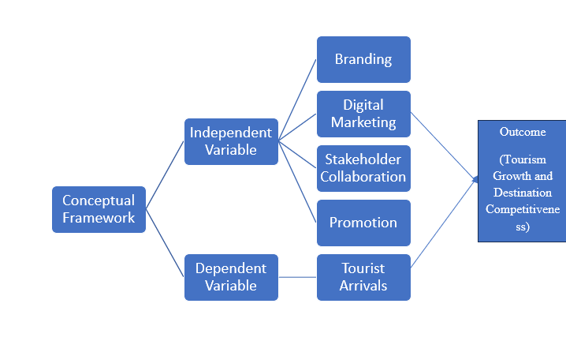
Figure 1: Conceptual Framework
(Source: Self-generated)

2.3 Review of Relevant Theories
This study is underpinned by three theories that explain how destination marketing influences tourists' perceptions and travel behaviour (Hernández-Ortega et.al. 2026). According to Hunt's Destination Image Theory, marketing communication, past experience, and external sources of information are the only basis on which tourists shape their perceptions of a destination (Liu and Huang, 2026). Positive destination image makes a consumer more likely to choose the destination and make a repeat visit; thus, the theory is relevant in comprehending the impact of marketing strategies on tourist arrivals (Xin et.al. 2026). The theory of AIDA explains the process of consumer decision-making using four distinct steps: Attention, Interest, Desire and Action. During destination marketing, promotional campaigns are supposed to attract the attention of tourists, create an interest to visit a destination, evoke a desire to visit and finally make a travel choice. The theory can thus be applied in the study of how the marketing activities relate to tourist arrivals (Jiang et al., 2022).
Lastly is the Integrated Marketing Communications (IMC) Theory, which focuses on the use of uniformity and integration of marketing messages through various channel communications. The theory states that integrating traditional advertising, digital marketing, social media and public relations will boost destination awareness and increase the confidence of the tourist in the destination (Maghrifani et al., 2022). Collectively, these theories can be used to provide us with a rich theoretical framework of destination marketing strategies, their impact on tourist attractions, and the problems and opportunities that lie in the context of new destination marketing.

2.4 Empirical Review
Destination Marketing Strategies
Hanna and Rowley (2021) note that destination marketing strategies entail destination branding, working in partnership with stakeholders, and combined communication to create a unique position on the market and enhance destination competitiveness. This is supported by the Destination Image Theory, which indicates that the image of a destination to tourists affects their intentions to travel and their behaviour decisions. According to Song and Wen (2021), the impact of promotional efforts, visitor experiences, and interactions between the stakeholders influences the image of the destination, which means branding is not limited to marketing communication. However, believe that online destination marketing has been the strategy of dominance in the sense that destination websites and online sites offer interactive knowledge, enhancing the level of awareness and travel intentions of tourists. Hanna and Rowley (2021) argue that online promotion is not sufficient to keep destinations competitive in the absence of a strategic branding strategy and efficient cooperation among stakeholders. On the contrary, when authentic visitor experiences come into play, destination perceptions are formed more strongly than promotional messages alone, proving that the process of destination marketing is more likely to affect destinations in an effective way when the elements of branding, digital communication, and experience are balanced.
Influence of Destination Marketing on Tourist Arrivals
Guo and Pesonen (2022) have found that destination marketing has one of the greatest influences on tourist arrivals because it allows destination marketing organisations to strategically distribute their promotional resources to the target markets, which enhances tourism demand and market performance. This view coincides with that of the AIDA Theory, which suggests that good marketing will attract the attention of tourists, create interest, arouse desire to travel and eventually lead to travel decisions. Following the Bădescu et al. (2025) perspective, the perception of the destination image through online travel reviews and digital communication influences the intention to visit the destination positively and enhances destination competitiveness. Nonetheless, destination marketing creates more impactful effects in promotional content that is interactive, credible, and emotionally appealing through official digital media that leads to more interactive behavioural responses. However, liberalisation of marketing funds as one factor does not always assume the subsequent growth in tourist visits; in reality, unless the promotional resources are effectively allocated to various source markets, as cited by Revida et al. (2022). On the other hand, trustworthy user-generated content, in comparison to the effectiveness of organisational promotional messages, may dictate the success of destination marketing, and thus authentic content created by visitors should be balanced with strategic promotional prominence.
Challenges and Opportunities in Destination Marketing
Molinillo, Anaya-Sánchez and Liébana-Cabanillas (2023) argue that destination marketing presents considerable challenges as the alteration of tourist expectations, swift technological changes, and even fierce rivalry demand that a destination constantly varies its marketing strategies. The Integrated Marketing Communications (IMC) Theory supports this argument as it highlights the fact that coherent and uniform communication via various media would amplify destination recognition and foster tourist interest. According to Makian et al. (2022), the preservation of a positive destination image has become more difficult in light of the impact of social media, whereby the experiences of tourists and their views can easily influence people's opinions. Nonetheless, Aburumman (2023) claims the existence of an attractive chance in digital technologies, such as artificial intelligence and data analytics, that help destination marketers to customise their promotional activities and enhance the overall experiences of tourists. However, Molinillo, Anaya-Sanchez and Liébana-Cabanillas (2023) argue that sufficient collaboration between tourism stakeholders and communication strategies would turn technological innovation into the key to successful marketing. On the other hand, they insist that long-term destination competitiveness is more concerned with sustaining a good destination image and the contentment of visitors than promotion, showing that sustainable destination marketing needs to be based on the balance between innovation, cooperation amongst stakeholders and destination image.

2.5 Literature Gap
The current literature has researched heavily in the areas of destination marketing, destination branding, digital marketing and destination image as areas that affect the travel behaviour of tourists and the competitiveness of destinations. The position of destination marketing organisations in the marketing of destinations via digital platforms, integrated communication and collaboration with stakeholders, has also been investigated in several studies. The results, though, are not very coherent as most reports are centred around specific areas of destination marketing, and lack a coherent assessment of marketing plans, their impact on the flow of tourists as well as the struggles and opportunities thereof under a single framework (Reinhold et al., 2023). Moreover, many past studies have incorporated a cross-country or multi-destination-based approach, so the insight into the process of destination marketing is constrained to a particular national destination marketing organisation. This paper thus fills these gaps by offering a holistic case study of VisitBritain, the amalgamation of destination marketing strategies, tourist arrivals, up-to-date marketing issues and prospects into a coherent analysis model.

2.6 Chapter Summary
This chapter explored the major concepts, theories, and empirical research in association with destination marketing and tourist arrivals. It has already pointed out the importance of destination marketing strategies and their role in determining tourism performance and the opportunities and challenges impacting destination competitiveness. Another significant research finding was that the chapter delineated key gaps in the literature to date and offered a conceptual framework, which should support a robust theoretical and empirical basis of the research approach that is described in the next chapter.

CHAPTER 3: RESEARCH METHODOLOGY

3.1 Introduction to Methodology
This chapter explained the methodology adopted to investigate the impact of destination marketing on tourist arrivals using VisitBritain as a case study. It introduced the research philosophy, approach, strategy, design, methodological choice and time horizon. It also discussed data collection, analytical procedures and ethical considerations applied throughout the research.

3.2 Methodological Framework: Application of Onion Model
The research process was systematically organised using Saunders' Research Onion as a methodological structure. The layers guided the selection of interpretivism, an inductive approach, a case study strategy, an exploratory design, a qualitative choice and a cross-sectional time horizon.
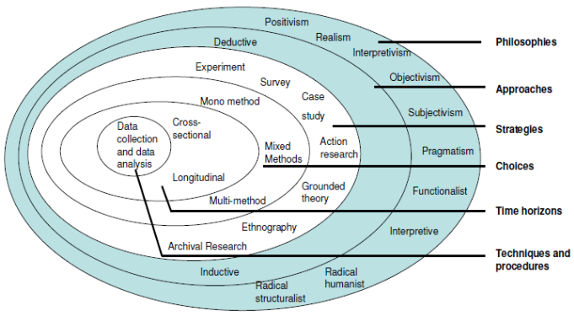
Figure 2: Saunders' Research Onion
(Source: ResearchGate, 2026)

3.2.1 Research Philosophy for the Dissertation
The philosophy adopted is interpretivism, which has been used because this study intends to understand how VisitBritain's activities of destination marketing have contributed to tourist attraction and arrival patterns (Saunders, Lewis and Thornhill, 2023). This philosophy was suitable given that this research investigated destination marketing as a socially and contextually shaped phenomenon as opposed to destination marketing as an outcome that can be objectively measured in terms of tourist arrivals. Positivism was not chosen as it had a primary focus on objective measurement, hypothesis testing and numerical relationships; these were less relevant to the exploratory and interpretive purpose of this study.

3.2.2 Research Approach for the Dissertation
An inductive approach has been adopted because the study developed understanding from existing observations, themes and evidence concerning VisitBritain's destination marketing activities and their relationship with tourist arrivals. The inductive approach facilitated the detection of patterns that developed in published academic research, industry reports and organisational documents before identifying broad interpretations (Behal, 2023). This approach proved to be appropriate, as the study aimed at investigating destination marketing strategies, their impact on tourist arrivals and problems and opportunities faced in attracting tourists. A deductive method was not chosen as it is often used to test an existing theory or hypothesis and derive conclusions from the empirical data, while this study aimed to gather information and insight based on existing information.

3.2.3 Research Strategies/Design for the Dissertation
A case study strategy has been adopted, with VisitBritain representing the central case through which destination marketing and tourist arrivals were examined. The case study strategy enabled detailed consideration of VisitBritain's marketing activities within the broader context of UK tourism (Jones-Hooker and Tyndall, 2023). The research also aimed to gain an understanding of the strategies, impacts, challenges and opportunities relating to destination marketing, which led to the employment of an exploratory design. A survey strategy was not chosen because numerical responses did not need to be obtained as a primary goal of the research to answer the research objectives. Likewise, an experimental design was not used because variables of marketing were, at that time, not manipulated and there were no controlled cause-and-effect situations.

3.2.4 Choices for the Dissertation
A qualitative approach has been used in this study as the research process was largely based on existing academic research (published papers), tourism reports, government publications and organisational publications to gain understanding of the VisitBritain destination marketing strategies and how they affect tourist numbers (Cheong et.al. 2023). A literature search to identify relevant literature used a systematic search strategy through academic databases and credible online sources (Hart, 2018). Search terms were then hyphenated, and the keywords that were hyphenated with one another were: VisitBritain, destination marketing, tourist arrivals, UK tourism marketing, destination promotion, tourist attraction, and tourism campaigns. Recent, relevant and credible sources were given priority; and, in cases where they were theoretically important, seminal studies were considered.

Table 1: Inclusion and Exclusion Criteria
Criteria | Inclusion Criteria | Exclusion Criteria
Publication type | Peer-reviewed studies. | Irrelevant studies.
Source credibility | Credible industry and government reports. | Unreliable websites.
Organisational sources | VisitBritain publications. | Sources not related to VisitBritain.
Language | English-language sources. | Sources in languages other than English.
Research relevance | Studies relevant to destination marketing, tourist arrivals and UK tourism. | Sources not related to destination marketing
Source duplication | Unique sources. | Duplicated sources.

3.2.5 Time Horizons for the Dissertation
A cross-sectional time horizon has been applied in this study as the research focused on existing evidence of VisitBritain's destination marketing as opposed to tracking marketing activity across a long period of time. The cross-sectional approach allowed the study to reflect on the current knowledge on destination marketing strategies, tourist flows, existing problems, and opportunities at the time of the study (Maier et.al. 2023). Selected literature and secondary sources were reviewed for updated knowledge about the selected research topic. A longitudinal time horizon was not selected because the research did not involve repeated data collection from the same sources across multiple periods

3.3 Data Collection Techniques
The study relied on secondary data collection because relevant evidence regarding VisitBritain's destination marketing activities and UK tourist arrivals was available through published sources. Academic journal articles were obtained through relevant scholarly databases, while reports and statistical information were collected from credible government, tourism and industry sources. VisitBritain publications and official tourism materials have been analysed to gain insight into VisitBritain's marketing strategy, its strategic priorities and its destination promotion activities (Pritchard, 2023).
Peer-reviewed literature was searched using a combination of pre-defined keywords on Google Scholar and the appropriate academic databases. Relevant and credible sources were selected according to the direct connection with the research objectives, which were also based on the date of publication (Schemm, 2023). Although the methodological structure initially considered primary data collection techniques, interviews and questionnaires were not selected because the research objectives could be addressed through extensive existing evidence and the study focused specifically on VisitBritain as a case. Secondary documentary sources thus became the most suitable sources for the research.

3.4 Analytical Techniques and Procedures
Thematic analysis was used to analyse the qualitative secondary data collected for the study. The academic papers, reports and organisational documents selected were analysed systematically in order to identify the common ideas that are relevant to the research goals. First, data on the relevant actions of VisitBritain in terms of destination marketing strategies, the number of visitors and problems and opportunities were identified and coded (Braun and Clarke, 2021). Broad themes reflecting the research questions were then formed from the similar codes. Themes were then compared across the selected sources and contrasted to see which themes matched and did not match, and to identify patterns. The analysis also helped to link evidence from industry and academic research to the case of VisitBritain (Walliman, 2020). The study did not have a primary numerical data set that needed statistical analysis, so this was not considered. Thematic analysis was therefore deemed to be suitable to investigate the evidence in a manner that was both contextual and interpretative.

3.5 Ethical Issues
Ethical principles were maintained throughout the study. Appropriate referencing and acknowledgement of all sources ensured academic integrity. Published information was reported clearly without misrepresentation (Rojas-Avila and Reynaldos-Grandón, 2023). Proper use of copyright: citations and paraphrasing. Informed consent and anonymity and confidentiality were not applicable because only secondary data were utilised. The fact that VisitBritain has been mentioned in Unsupported claims was not included.

3.6 Chapter Summary
This chapter introduced the methodological approach used to explore the issue of destination marketing and tourist numbers using the VisitBritain case. Interpretivism, an inductive approach, case study strategy, exploratory design, qualitative choice, secondary data collection, thematic analysis and a cross-sectional time horizon were selected as appropriate methodological components. The chapter also established the search, inclusion and exclusion criteria and addressed ethical considerations. These decisions gave a solid basis for addressing the research goals.

CHAPTER 4: ANALYSIS AND DISCUSSION OF RESULTS

4.1 Introduction
The analysis and discussion of the findings with regard to destination marketing and tourist arrivals for the case study of VisitBritain is presented in this Chapter. The results are presented in three themes, which correspond to the research objectives: Destination marketing strategies, Effect of marketing on tourist numbers and Destination marketing challenges and opportunities. Thematic coding and analysis are first presented in the chapter, and then the findings are discussed in relation to the literature review and relevant theories for this research.

4.2 Presentation of Results
Table 1 Thematic Coding Table
Final theme | Codes generated | Keywords or short findings of article | Author
Theme 1: Destination Marketing Strategies | Promotional videos; destination image; visual communication; tourist perception | Tourist destination promotion videos have the potential to affect the tourist perception and understanding of a tourist destination. | Zuo, B., Tsai, C.H.K., Su, C.H.J., Jantes, N., Chen, M.H. and Liu, J. (2023)
 | Sports partnerships; destination promotion; audience reach; strategic collaboration | Sports franchise partnerships can offer extra promotional opportunities and reach for destinations as well. | Proctor, D., Dunne, G. and Flanagan, S. (2023)
 | Technology adoption; digital promotion; visitor communication; tourism innovation | Tourism marketing and communications with potential tourists are evolving with technological development. | Dar, H. and Dar, M.A. (2025)
Theme 2: Marketing Impact on Tourist Arrivals | The promotion of tourism, generation of demand, destination visibility and attracting visitors. | The promotion of tourism can increase tourism demand by increasing the visibility of the destination and promoting tourism visits. | Florido-Benítez, L. (2025)
 | Cultural preferences; tourism demand; market understanding; visitor behaviour | There are differences between various cultures that affect tourist demand, and knowledge of tourists' market segments is essential in promoting a market segment. | Tang, P. and Zhang, J. (2025)
 | Marketing planning; brand equity; tourist interest; destination performance | Tourism planning and marketing can help to build the destination brand equity to drive tourist interest and destination performance. | Ruiz-Meza, J., Sotaquirá, R. and Montoya-Torres, J.R. (2024)
Theme 3: Challenges and Opportunities in Destination Marketing | The pressure of climate change, the NTO response, destination positioning and sustainable promotion. | Climate change puts pressure on national tourism organisations to reconsider the presentation and positioning of destinations | Gössling, S., Vogler, R., Humpe, A. and Chen, N. (2024)
 | Sustainability challenges; technology; competition; branding opportunities | The challenges of the environmental, technological and competitive aspects of destination branding can be seen as opportunities for sustainable tourism development. | Aman, E.E., Papp-Váry, Á.F., Kangai, D. and Odunga, S.O. (2024)
 | AI marketing; personalisation; data concerns; implementation challenges | AI brings both opportunities for customised tourism marketing and ethical, data and implementation challenges. | Bulchand-Gidumal, J., William Secin, E., O’Connor, P. and Buhalis, D. (2024)

4.3 Data Analysis/Results
Theme 1: Destination Marketing Strategies
The results of Theme 1 demonstrate that pictorial promotion, partnerships and technology are becoming more important in destination marketing. According to Zuo et al. (2023), promotional videos can affect the destination image by creating the perception of a destination among potential tourists. This indicates that VisitBritain can leverage visuals to establish positive references to Britain and stimulate interest in its audience. The value of this strategic partnership is shown by the work of Proctor et al. (2023), who demonstrate that partnerships through sports franchises can increase the reach of promotions and bring destinations to the attention of a broader audience. There are potential opportunities for VisitBritain to engage in such partnerships to help its campaigns connect with sporting events and to enhance the breadth of its international visibility. According to Dar and Dar (2025), technology plays an important role in tourism marketing and communication. This means that digital platforms and technologies can play a role in VisitBritain's promotional activities, reaching out to the right and engaging audiences. In general, the results show that destination marketing by means of visual storytelling, collaborative promotion and technological innovation is necessary to enhance the destination appeal.
Theme 2: Marketing Impact on Tourist Arrivals
Theme 2 suggests that marketing can help to drive tourist numbers through increased visibility, understanding of tourist markets and enhanced appeal. Florido-Benítez (2025) suggests that tourism promotion can play its part by raising awareness and helping to stimulate consideration of tourist destinations. This implies that when Britain's attractions and experiences are promoted in VisitBritain's promotional campaigns, tourism may be promoted. In a previous study, Tang and Zhang (2025) demonstrated that cultural differences would affect tourism demand; therefore, it is essential to have a grasp of the markets. Promotional activities should be sensitive to differences in cultural preferences, motives and expectations of tourists, and should not assume a single message for all. Ruiz-Meza et al. (2024) also demonstrate that the process of tourism planning and marketing may boost brand equity, which, in turn, may affect the interest and performance of tourists.
Theme 3: Challenges and Opportunities in Destination Marketing
Theme 3 highlights challenges and opportunities in destination marketing. The study by Gössling et al. (2024) indicates that there are forces at play that are requiring national tourism organisations to rethink destination positioning and communication in the context of climate change. VisitBritain's challenge here is to promote tourism, whilst addressing environmental concerns and the changing expectations of tourists. Aman et al. (2024) outline the opportunities for sustainable development and innovative strategies, as well as the environmental, technological and competitive pressures in destination branding strategies. This indicates a need for VisitBritain to reinforce its brand through the lens of sustainability. Bulchand-Gidumal et al. (2024) point out the opportunities provided by AI in personalised tourism marketing, alongside specific ethical, data-related and implementation-related issues. With the responsible use of technology, VisitBritain can do better at targeting and adapt communication accordingly. The results indicate that there is a need for a balance between sustainability, competition, technological change and ethics in destination marketing.

4.4 Discussion of the Findings in Relation to Theoretical Framework
Destination Marketing Strategies
VisitBritain's destination marketing strategies can be compared to the literature review in terms of the emphasis on coordinated promotion and destination image. The literature review conducted by Hanna and Rowley (2021) highlighted that branding, collaboration with stakeholders, and integrated communication are essential to destination marketing, which is not restricted to internet marketing. Song and Wen (2021) pointed out that the visitor experiences and stakeholder interactions are important factors that influence destination image. These ideas are supported by the findings; promotional videos were deemed helpful in destination perceptions by Zuo et al. (2023), and sports partnerships were shown to enhance promotional reach by Proctor et al. (2023). The findings, however, focus on certain promotional tools, while the literature review offers a wider strategic approach. The relationship is explained in Hunt's Destination Image Theory, which states that marketing communication has an impact on tourists' perception of the destination. The use of a range of promotional activities by VisitBritain can help to shape positive destination images and shape travel decisions.
Marketing Impact on Tourist Arrivals
The results regarding the impact of VisitBritain's marketing generally support the findings of the literature review, especially for the areas of visibility, targeting and destination interest and demand. The literature review carried out by Guo and Pesonen (2022) highlighted that the management of promotional resources to target markets can help to boost tourism demand and market performance. According to Bădescu et al. (2025), trustworthy and expressive digital communication has an impact on the decision to visit. Likewise, it is observed that Florido-Benítez (2025) has linked the promotion of tourism with the increase in the visibility of the destination and tourist demand, whereas Ruiz-Meza et al. (2024) have connected the marketing planning with an increase in tourist interest and the existence of good brand equity for a tourist destination. The literature has received more focus on digital credibility and resource allocation, whereas the findings have focused on visibility and branding. The AIDA theory, which Jiang et al. (2022) discussed, describes how effective promotion can grab attention, create interest and desire and encourage tourists to take action.
Challenges and Opportunities in Destination Marketing
The results for challenges and opportunities are indicative of the challenges that were identified in the literature review, but focus more on technological and sustainability pressures. The tourism literature reviewed by Reinhold et al. (2023) highlighted the importance of destinations continuously adapting to the changing expectations of tourists, technological advances and the competition. Tourist opinions can easily flow through social media and therefore destination image management can be challenging, as mentioned by Makian et al. (2022). AI and data analytics were also cited as opportunities for personalised promotion and enhanced experiences by Gato (2022). These findings align with these arguments, with the challenges and opportunities found by Aman et al. (2024) being sustainability, technology and competition, and those identified by Bulchand-Gidumal et al. (2024) being AI personalisation, data and implementation. According to the theory of Integrated Marketing Communications presented by Maghrifani et al. (2022), coordinated communication can assist VisitBritain to overcome these situations.

4.5 Chapter Summary
The findings and discussion of VisitBritain's destination marketing and the impact on the number of tourists visiting were presented in this chapter. Thematic analysis yielded three themes: destination marketing strategies, the impact of marketing on tourist numbers and challenges and opportunities in destination marketing. The results revealed that visual promotion, strategic partnerships, and technological development were factors to consider concerning destination marketing. They were discussed with the literature, and areas of agreement and difference were highlighted. VisitBritain's marketing activities, destination perceptions, tourist decisions and the effectiveness of communication were explained by Hunt's Destination Image Theory, AIDA Theory and Integrated Marketing Communications Theory in the study.

CHAPTER 5: CONCLUSIONS AND DISCUSSION

5.1 Introduction
This chapter outlines the main conclusions of the study for destination marketing and tourism arrivals using the VisitBritain case study. It presents a summary of the findings, recommendations, limitations and future research.

5.2 Summary of Findings
The results of this research met all three research objectives, as they focused on the influence of destination marketing on tourist arrivals, focusing on the VisitBritain case. The first objective (VisitBritain's destination marketing strategies) was met by defining the importance of visual marketing, strategic partnerships and the use of digital technologies as key strategies. These strategies help to make the destination visible, build up its image and communicate with potential visitors.
The second objective, which aimed to explore the effect of destination marketing on the number of tourists, was met through the evidence provided, which demonstrates that destination marketing can raise destination awareness, create tourist interest and build up destination brand equity. The results also highlighted the need to identify cultural differences and tourists' preferences for developing marketing messages that can impact tourist behaviour.
The third objective, to identify challenges and opportunities, was achieved by emphasising climate change, technological advances, the intensification of competition and the rise of artificial intelligence. These factors create challenges for destination marketers but also provide opportunities for more sustainable, innovative and personalised marketing. The overall results show that integrated and flexible destination marketing can be an instrument to draw tourists and reinforce the competitiveness of destinations.

5.3 Recommendations
Strengthen digital and visual marketing: VisitBritain must create more engaging videos, social media content and interactive digital campaigns to build visibility of the country and promote positive perceptions for the benefit of international tourists (Maghrifani et.al. 2022).
Expand strategic partnerships: VisitBritain should forge collaborations with sport organisations, travel companies, airlines, events and other tourism stakeholders to enhance tourism promotions, raise the profile of Britain as a tourist destination and boost the flow of tourists to Britain (Khemraj, 2024).
Adopt sustainable and personalised technologies: Use AI and data analytics to tailor visitor marketing and to gain insights into evolving visitor preferences for VisitBritain.

5.4 Limitation of the Study
The findings of this study should be considered in light of its limitations. The first limitation was that the study depended totally on secondary data sources in the form of academic literature, reports and organisation sources. Thus, the study was not able to gain direct access to any of the VisitBritain staff, tourism businesses or tourists. Second, the qualitative approach obtained a detailed understanding of marketing strategies, while the thematic analysis method did not provide opportunities for statistically testing a direct causal relationship between destination marketing and tourist arrivals. Third, the study was specific to VisitBritain, and therefore the findings are not generalisable to other national tourism organisations. Furthermore, the study could not easily separate the influence of destination marketing from other factors affecting tourist arrivals, such as economic conditions, global crises, changes in visitor preferences and competition (Srinivasan et.al. 2024).

5.5 Suggested Areas for Future Research
Further research could build on this work by gathering primary data from VisitBritain professionals, the tourism industry and international tourists to gain first-hand insights into the effectiveness of the destination marketing. Further quantitative studies might also explore the linkage between specific marketing initiatives, including social media marketing, electronic advertising and marketing and collaborations, and genuine tourist numbers through statistical analysis. Comparative research between VisitBritain and other national tourism organisations may offer general lessons as to the differences in destination marketing strategy and its results. Further research in the future should explore the impact of AI, data analysis, and tailored digital marketing on tourist choices. A second potentially useful research area would be exploring sustainable destination marketing and the influence of the environment on tourists' perceptions and travel intent (Walliman, 2020). Evaluation of marketing over a number of years using longitudinal studies could also be conducted to establish the relationship between the changing marketing strategies and the changes in tourist numbers and the competitiveness of the destination.

5.6 Conclusion
The study indicates that the role of destination marketing in enhancing the visibility of a destination and its image is significant and has an impact on the interest of tourists. VisitBritain's digital promotion, partnerships and technology can help to bring visitors to Britain. But destination competitiveness demands constant change due to sustainability, competition, and technology issues.

REFERENCES

Aman, E.E., Papp-Váry, Á.F., Kangai, D. and Odunga, S.O. (2024) Building a sustainable future: Challenges, opportunities, and innovative strategies for destination branding in tourism. Administrative Sciences, 14(12), p.312. https://doi.org/10.3390/admsci14120312
Aripin, Z., Susanto, B. and Sikki, N. (2024) Unraveling the effects of economic policy uncertainty: strategic contributions of marketing, operations, and research and development. Kriez academy: Journal of development and community service, 1(2), pp.52-64. http://kriezacademy.com/index.php/kriezacademy/article/view/11
Bădescu, L.I., MeseȘan-Schmitz, L. and Nechita, F. (2025) Digital Communication and the Impact of Online Review Platforms on Visiting Behaviour. Bulletin of the Transilvania University of Brasov. Series VII, Social Sciences and Law, 18(2), pp.417-426. https://www.ceeol.com/search/article-detail?id=1402417
Behal, A. (2023) Inductive process to analyse the structure of lived experience: a scholar-practitioner protocol for evidence-based practice in qualitative research. International Journal of Qualitative Methods, 22, p.16094069231220146. https://journals.sagepub.com/doi/full/10.1177/16094069231220146
Blanco-Moreno, S., González-Fernández, A.M. and Muñoz-Gallego, P.A. (2024) Big data in tourism marketing: past research and future opportunities. Spanish journal of marketing-esic, 28(3), pp.266-286. https://doi.org/10.1108/SJME-06-2022-0134
Braun, V. and Clarke, V. (2021) Can I use TA? Should I use TA? Should I not use TA? Comparing reflexive thematic analysis and other pattern‐based qualitative analytic approaches. Counselling and psychotherapy research, 21(1), pp.37-47. https://doi.org/10.1002/capr.12360
Bulchand-Gidumal, J., William Secin, E., O’Connor, P. and Buhalis, D. (2024) Artificial intelligence’s impact on hospitality and tourism marketing: exploring key themes and addressing challenges. Current Issues in Tourism, 27(14), pp.2345-2362. https://doi.org/10.1080/13683500.2023.2229480
Cheong, H.I., Lyons, A., Houghton, R. and Majumdar, A. (2023) Secondary qualitative research methodology using online data within the context of social sciences. International Journal of Qualitative Methods, 22, p.16094069231180160. https://doi.org/10.1177/16094069231180160
Dar, H. and Dar, M.A. (2025) Redefining success of the tourism sector through technological advancements. In AI technologies for personalized and sustainable tourism (pp. 201-214). IGI Global Scientific Publishing. 10.4018/979-8-3693-5678-4.ch008
Florido-Benítez, L. (2025) Tourism promotion as a marketing tool to enhance tourism demand in the eight provinces of Andalusia. Discover Cities, 2(1), p.52. https://doi.org/10.1007/s44327-025-00084-0
Gato, M., Dias, Á., Pereira, L., da Costa, R.L. and Gonçalves, R. (2022) Marketing communication and creative tourism: An analysis of the local destination management organisation. Journal of Open Innovation: Technology, Market, and Complexity, 8(1), p.40. https://doi.org/10.3390/joitmc8010040
Gössling, S., Vogler, R., Humpe, A. and Chen, N. (2024) National tourism organizations and climate change. Tourism Geographies, 26(3), pp.329-350. https://doi.org/10.1080/14616688.2024.2332368
Guo, X. and Pesonen, J.A. (2022) The role of online travel reviews in evolving tourists’ perceived destination image. Scandinavian Journal of Hospitality and Tourism, 22(4-5), pp.372-392. https://doi.org/10.1080/15022250.2022.2112414
Hanna, S. and Rowley, J. (2021) 'Place and destination branding: A review and conceptual mapping of the domain', European Management Review, 18(2), pp. 105–117. https://doi.org/10.1111/emre.12433
Hart, C. (2018) Doing a Literature Review: releasing the research imagination. 2nd edn. London: Sage. https://sk.sagepub.com/book/mono/doing-a-literature-review-2e/toc
Hernández-Ortega, B., Herrero, Á., Martín, H.S. and Franco, J.L. (2026) How destination image projected on social media influences online sales of tourism services: exploring the moderating role of tourists’ experience. Current Issues in Tourism, 29(2), pp.213-220. https://doi.org/10.1080/13683500.2024.2422988
Jiang, J., Hong, Y., Li, W. and Li, D. (2022) 'A study on the impact of official promotion short videos on tourists' destination decision-making in the post-epidemic era', Frontiers in Psychology, 13, 1015869. https://doi.org/10.3389/fpsyg.2022.1015869
Jones-Hooker, C. and Tyndall, D.E. (2023) Application of case study research and ethnography methods: Lessons learned. Applied Nursing Research, 73, p.151713. https://doi.org/10.1016/j.apnr.2023.151713
Khemraj, S. (2024) Evolution of Marketing Strategies in the Tourism Industry. Intersecta Minds Journal, 3(2), pp.45-64..45-64. https://so13.tci-thaijo.org/index.php/IMJ/article/view/574
Liu, B. and Huang, A. (2026) Digital economy and tourism growth: the role of online attention allocation and transportation infrastructure. Tourism Review, 81(2), pp.931-949. https://doi.org/10.1108/TR-07-2024-0565
Maghrifani, D., Liu, F. and Sneddon, J. (2022) Understanding potential and repeat visitors’ travel intentions: the roles of travel motivations, destination image, and visitor image congruity. Journal of Travel Research, 61(5), pp.1121-1137. https://journals.sagepub.com/doi/abs/10.1177/00472875211018508
Maier, C., Thatcher, J.B., Grover, V. and Dwivedi, Y.K. (2023) Cross-sectional research: A critical perspective, use cases, and recommendations for IS research. International journal of information management, 70, p.102625. https://www.sciencedirect.com/science/article/abs/pii/S0268401223000063
Makian, S., Gursoy, D. and Kaurav, R.P.S. (2022) Online tourism communication in destination image formation. Handbook on tourism and social media. Edward Elgar Publishing, pp.68-80. https://www.researchgate.net/profile/Sarasadat-Makian/publication/358785927_Online_tourism_communication_in_destination_image_formation/links/639c978e024dc52c8a25ef9f/Online-tourism-communication-in-destination-image-formation.pdf
Morrison, A.M. (2023) Marketing and managing tourism destinations. Routledge. https://doi.org/10.4324/9781003343356
Pritchard, K. (2023) Reimagining secondary data in a digital age. https://doi.org/10.1108/S1479-838720220000014002
Proctor, D., Dunne, G. and Flanagan, S. (2023) Towards a model of sports franchise leverage for destination marketing. Journal of Destination Marketing & Management, 30, p.100829.www.sciencedirect.com
Reinhold, S., Beritelli, P., Fyall, A., Choi, H.S.C., Laesser, C. and Joppe, M. (2023) State-of-the-art review on destination marketing and destination management. Tourism and Hospitality, 4(4), pp.584-603. https://doi.org/10.3390/tourhosp4040036
ResearchGate, (2026), Saunders Research Onion, (Online). Accessed from< https://www.researchgate.net/figure/The-research-onion-research-design-Source-Adopted-from-Saunders-et-al-2007_fig2_309990456> accessed on 31 August 2026.
Revida, E., Munthe, H.M. and Purba, S. (2022) Increasing tourist visits through the development model of tourism village based on local culture. Journal of Environmental Management & Tourism, 13(4), pp.1151-1160. https://www.ceeol.com/search/article-detail?id=1096353
Rojas-Avila, J. and Reynaldos-Grandón, K.L. (2023) Exchange of secondary data in research with human beings: Ethical aspects. 10.56294/saludcyt2023432
Ruiz-Meza, J., Sotaquirá, R. and Montoya-Torres, J.R. (2024) Effects of tourism planning and marketing strategies on destination brand equity: A system dynamics model. Journal of Simulation, 18(3), pp.360-377. https://doi.org/10.1080/17477778.2022.2102945
Saunders, M., Lewis, P. and Thornhill, A. (2023) Research Methods for Business Students. 8th edn. Harlow: Prentice Hall. https://amberton.edu/wp-content/uploads/2024/07/RGS6035_E2_Fall2024.pdf
Schemm, N. (2023) Identifying credible sources. Professional Safety, 68(2), pp.18-20. https://www.proquest.com
Song, J.Y. and Wen, I. (2021) 'Factors Affecting DMO's Website Use Intention, and Visiting Intention: A SEM Model on the Impact of E-Destination Image and DMO's Website Design', Journal of Tourism and Hospitality Management, 9(4), pp. 183–203. https://doi.org/10.17265/2328-2169/2021.04.001
Sorokina, E., Wang, Y., Fyall, A., Lugosi, P., Torres, E. and Jung, T. (2022) Constructing a smart destination framework: A destination marketing organisation perspective. Journal of Destination Marketing & Management, 23, 100688. https://doi.org/10.1016/j.jdmm.2021.100688
Srinivasan, S., Sherkar, A., Jayamani, J., Indora, A. and Mukherjee, R. (2024) Tourism innovation and the role of technology in enhancing visitor experiences. Educational Administration: Theory and Practice, 30(4), pp.1506-1513. 10.53555/kuey.v30i4.1702
Tang, P. and Zhang, J. (2025) How cultural differences affect outbound tourism demand?. Journal of Hospitality and Tourism Management, 62, pp.128-134. www.sciencedirect.com
Walliman, N. (2020) Your Research Project: Designing, Planning, and Getting Started. 4th edn. London: Sage. https://sk.sagepub.com/book/mono/your-research-project-4e/toc
Xin, X., Li, J., Li, Y. and Liu, W. (2026) From sharing to reactivating: how social media sharing reconfigures tourists’ memory, destination image, and revisit intention. Asia Pacific Journal of Tourism Research, pp.1-27. https://doi.org/10.1080/10941665.2026.2728723
Zuo, B., Tsai, C.H.K., Su, C.H.J., Jantes, N., Chen, M.H. and Liu, J. (2023) Formation of a tourist destination image: Co-occurrence analysis of destination promotion videos. Journal of Destination Marketing & Management, 27, p.100763. www.sciencedirect.com

Appendix A – Reflective Statement

The dissertation writing process was a good learning process for me, as it gave me a chance to learn about destination marketing and how marketing activities can affect tourism. Initially, I knew that destination marketing existed, but I gained a much better understanding of how it could be used to build awareness of the destination, build a positive image and attract visitors. The research process was difficult as I had to be able to choose academic resources that were relevant to my research and was not sure as to which information was the most useful to my study. I had to compare various views carefully and not take one source for granted when using secondary sources. I also discovered the necessity of structuring information within themes to enable the findings to be linked clearly with the research objectives.
By selecting VisitBritain for the case study, I have understood the application of digital promotion, images, partnership and technology in destination promotion. Additionally, I was made more aware of the fact that marketing does not operate in isolation; competition, sustainability, tourist preferences and technological developments can influence the results of marketing.
Yet another lesson for me was that I had to maintain academic integrity during the dissertation. I developed my skills in referencing, presenting information in my own words and linking information, purpose, methodology and findings to a coherent whole. In general, the research that I have completed has enhanced my research, analytical writing and academic writing skills. Accessing, identifying and summarising key points from academic literature is now more confident. This has also shown me the importance of critically approaching the subject matter I am studying at the academic level.

Appendix B – Evidence of Ethics Form Approval

GBS Green Research or Placement Project Proposal
and
Ethics Approval Form

All sections of the form should be completed. You must append, at the end of this form, all of the materials for your project. The staff member reviewing this form needs to see full details of what your participants will experience. In completing this form, you must follow the guidance provided by your subject area.

Unless otherwise instructed, this form must be submitted electronically via Moodle.

PART A: Summary

A1. Programme:
A2. Project title: | The Impact of Destination Marketing on Tourist Arrivals: A Case Study of VisitBritain.
A3. Student’s name:
A4. GBS email address:
A5. Dissertation supervisor:
A6. Date of submission:

A7. Project Summary: This research paper explores which effects destination marketing can have on tourist arrivals using the case study of VisitBritain. It uses a qualitative type whereby secondary data was gathered in terms of books, journals, articles, government publishing, and VisitBritain reports. Thematic analysis will be used to analyse the data to establish the main marketing strategies, its impact on tourists arrivals and associated challenges as well as opportunities.

Aim of the study:
The aim of this research is to investigate the impact of destination marketing on tourist arrivals, using VisitBritain as a case study.
Objectives:
To examine the destination marketing strategies used by VisitBritain.
To analyse the impact of VisitBritain's destination marketing on tourist arrivals.
To identify the challenges and opportunities of destination marketing in attracting tourists through VisitBritain.
Research Questions:
What destination marketing strategies are used by VisitBritain?
How does VisitBritain's destination marketing influence tourist arrivals?
What are the main challenges and opportunities of destination marketing in attracting tourists through VisitBritain?
What type of data?
This study uses qualitative data. The study gathers and interprets non-quantitative data as secondary materials including academic journals and books, industry reports, and VisitBritain publications to gain knowledge of destination marketing and how it affects visitor arrivals.
What data collection methods will be used?
This study uses the secondary data collection method. The current published resources will be used to collect data on destination marketing strategies and influences upon the arrival of tourists using VisitBritain.
Where will be data collected?
Books, academic journals, research articles, government publications, VisitBritain reports, industry reports, and other sources that contain reliable information concerning destination marketing and tourism will be utilized in data collection.
What keywords will be used?
The main keywords include: destination marketing, tourist arrival, VisitBritain, tourism promotion, destination branding, tourism marketing, visitor behaviour, tourism development, marketing strategies and the United Kingdom tourism.
What analysis method will be used?
The present paper employs the thematic analysis to analyze the secondary data. The approach enumerates, structures, and decorates significant themes and trends pertaining to destination marketing and its impact on tourist rates.

PART B: DECLARATION
In completing this form, have you followed the guidance provided by your supervisor?
YES ☒ NO ☐

I confirm that I have had appropriate training (Did you watch the video in the Moodle?).

YES ☒ NO ☐
RESEARCHER DECLARATION:
I certify that the information contained in this application is accurate.
I confirm that I have attempted to identify the risks that may arise in conducting this research and acknowledge my obligations and the rights of the participants.
I confirm that I am aware of and have adhered to the health and safety policy of the organisation in which I am conducting my research, including GBS or any other organisation, and that I have appended this and any required Health and Safety risk assessment documentation to my ethics application.

YES ☒ NO ☐

Name of researcher/student:
Date:
TO BE COMPLETED BY THE DISSERTATION SUPERVISOR:
I confirm that I have checked the form and the related materials and agree that, in addition to general ethical issues, the matters listed above have been specifically addressed.

YES ☐ NO ☐

Name of the Supervisor:

Date:

Appendix C – Individual Digital Log

Appendix D – Data

Table 3 Review of Selected Articles
Author | Findings of articles | Methodology
Zuo et al. (2023) | Tourist perceptions can be influenced by destination promotional videos and can increase the understanding of a destination. | A qualitative study related to destination promotion and tourist perceptions.
Proctor, Dunne and Flanagan (2023) | Partnerships with sports franchises can provide valuable promotional opportunities and increase destination reach. | Qualitative analysis of sports and destination partnerships based on the cases.
Dar and Dar (2025) | Tourism marketing is changing and communication with tourists is improving via technological developments, digital channels. | Technology and Tourism Marketing practice, qualitative Review.
Florido-Benítez (2025) | Promotion can enhance the visibility of the destination and stimulate demand, motivating prospective tourists to consider travelling to the destination. | Secondary research examining tourism promotion and destination demand.
Tang and Zhang (2025) | Local differences of culture will affect the volume of tourists; hence knowledge of tourists preference is important in destination marketing. | Quantitative analysis of cultural differences and tourist demand.
Ruiz-Meza, Sotaquirá and Montoya-Torres (2024) | Planning and marketing for tourism can enhance destination brand equity to make it more attractive to tourists and improve destination performance. | Qualitative research on tourism planning, marketing and brand equity.
Gössling, Vogler, Humpe and Chen (2024) | Climate change brings pressure to national tourism organisations to rethink positioning and marketing communication. | Qualitative analysis of climate change and national tourism organisation responses.
Aman et al. (2024) | Environmental, technological and competitive challenges can create opportunities for sustainable tourism. | Qualitative review of tourism branding and sustainability issues.
Bulchand-Gidumal et al. (2024) | Artificial intelligence supports personalised tourism marketing but raises concerns about data, ethics and implementation. | Qualitative review of AI applications and challenges in tourism.

Appendix E – Results

Zuo et al. (2023)

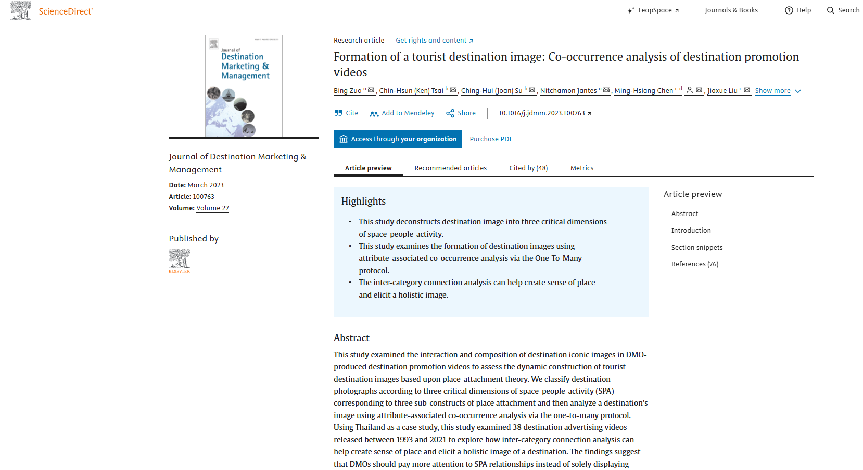

Proctor, Dunne and Flanagan (2023)

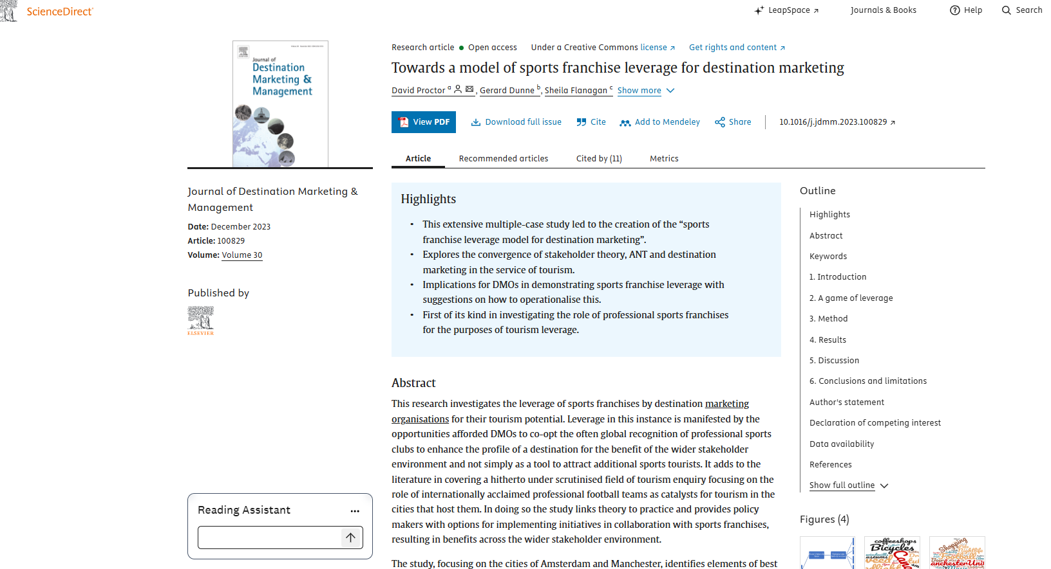

Dar and Dar (2025)

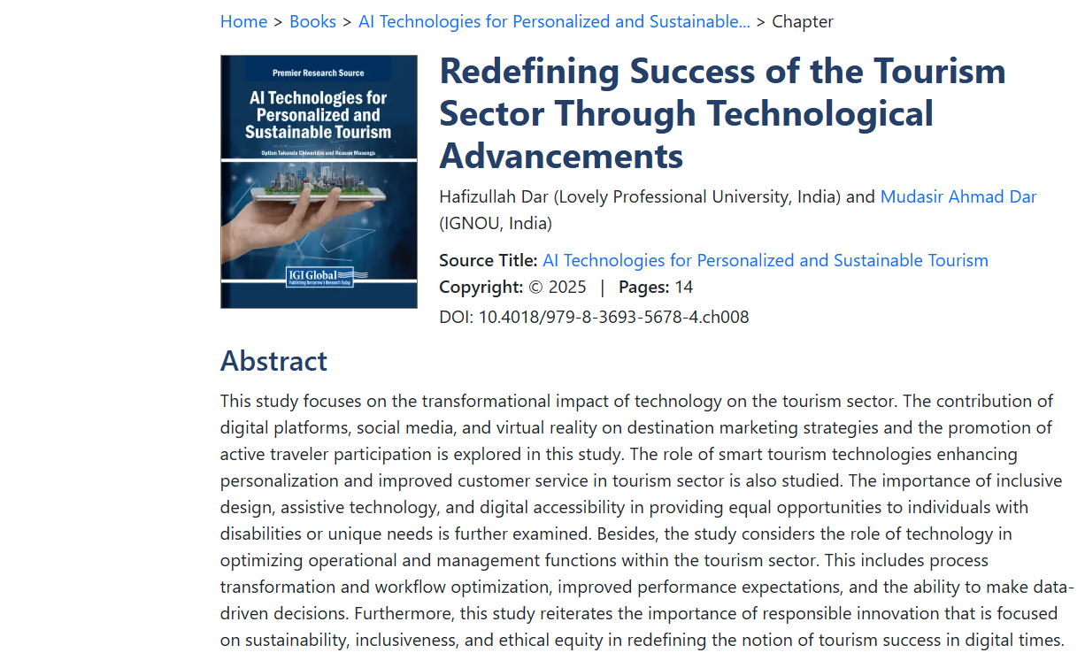
Florido-Benítez (2025)

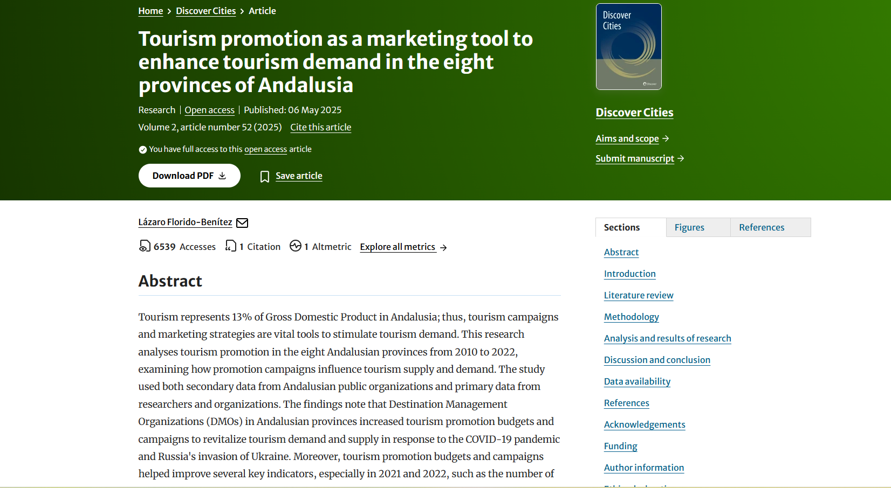

Tang and Zhang (2025)

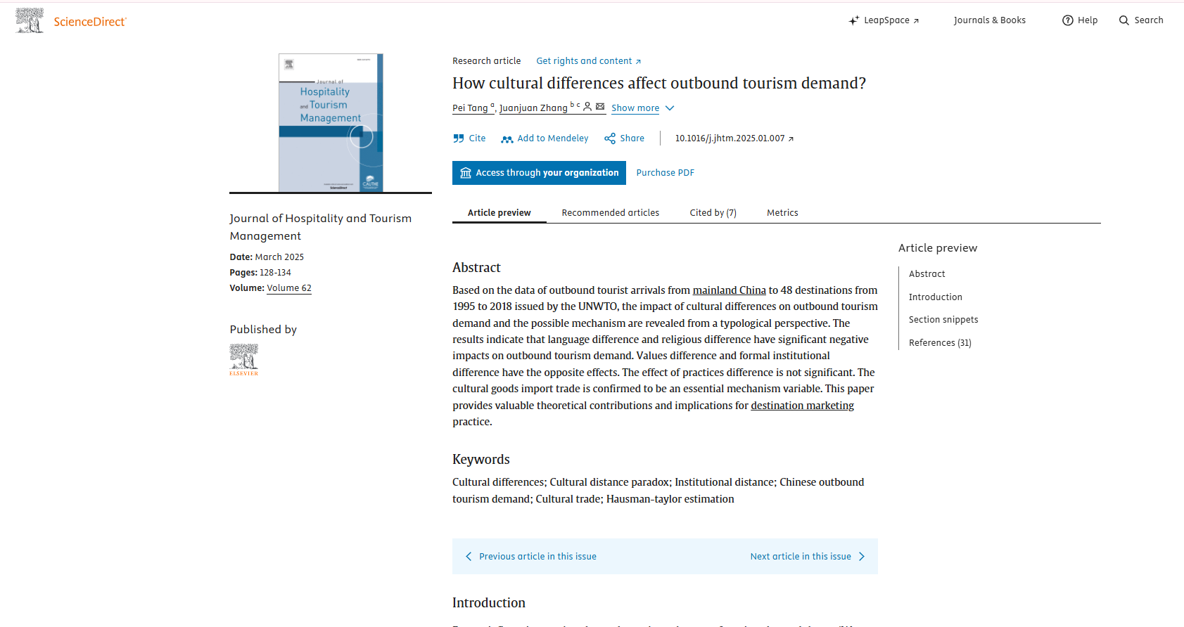

Ruiz-Meza, Sotaquirá and Montoya-Torres (2024)

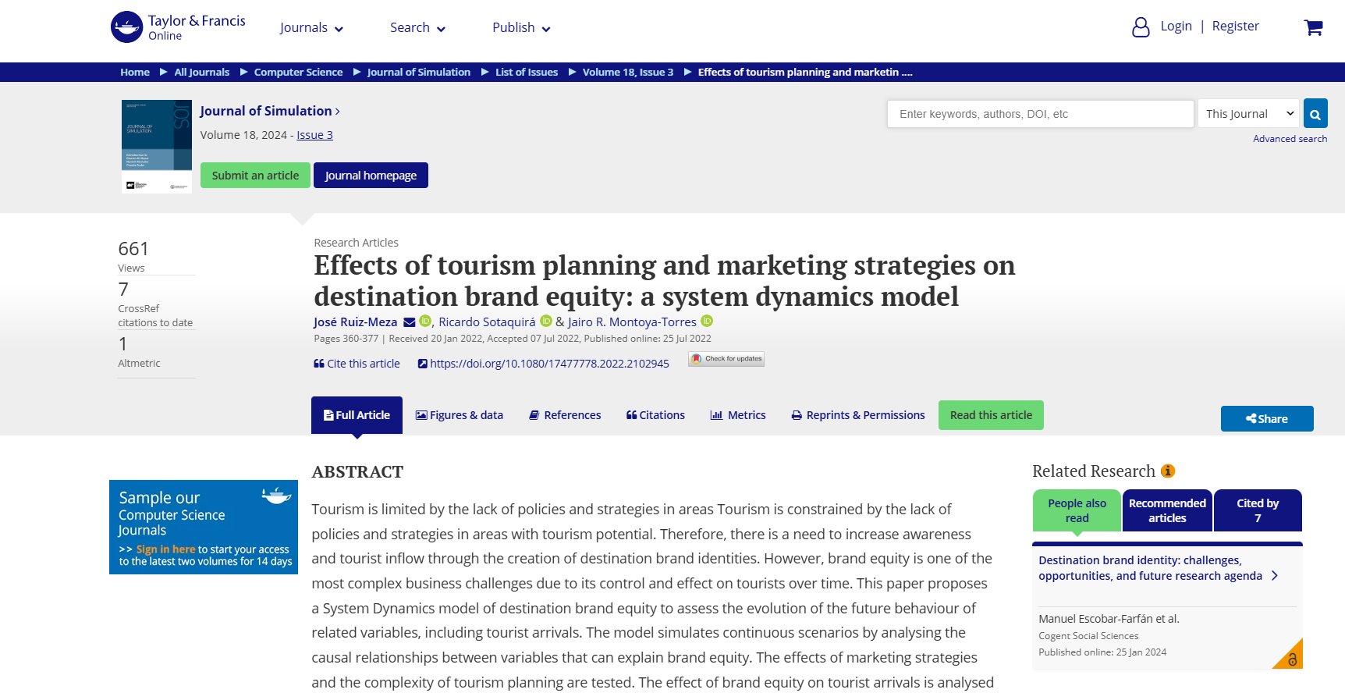
Gössling, Vogler, Humpe and Chen (2024)

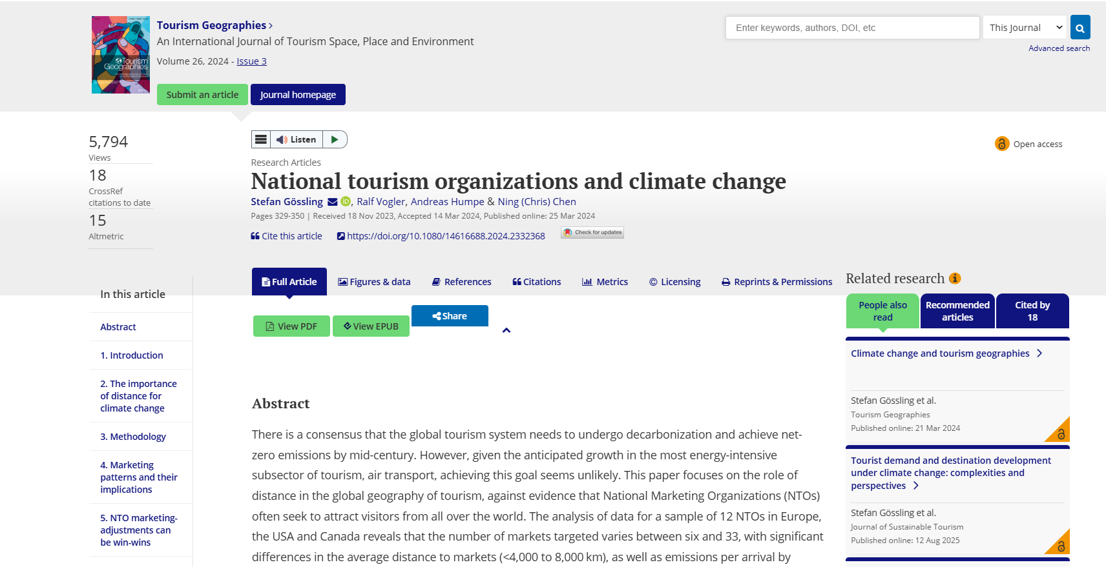

Aman et al. (2024)
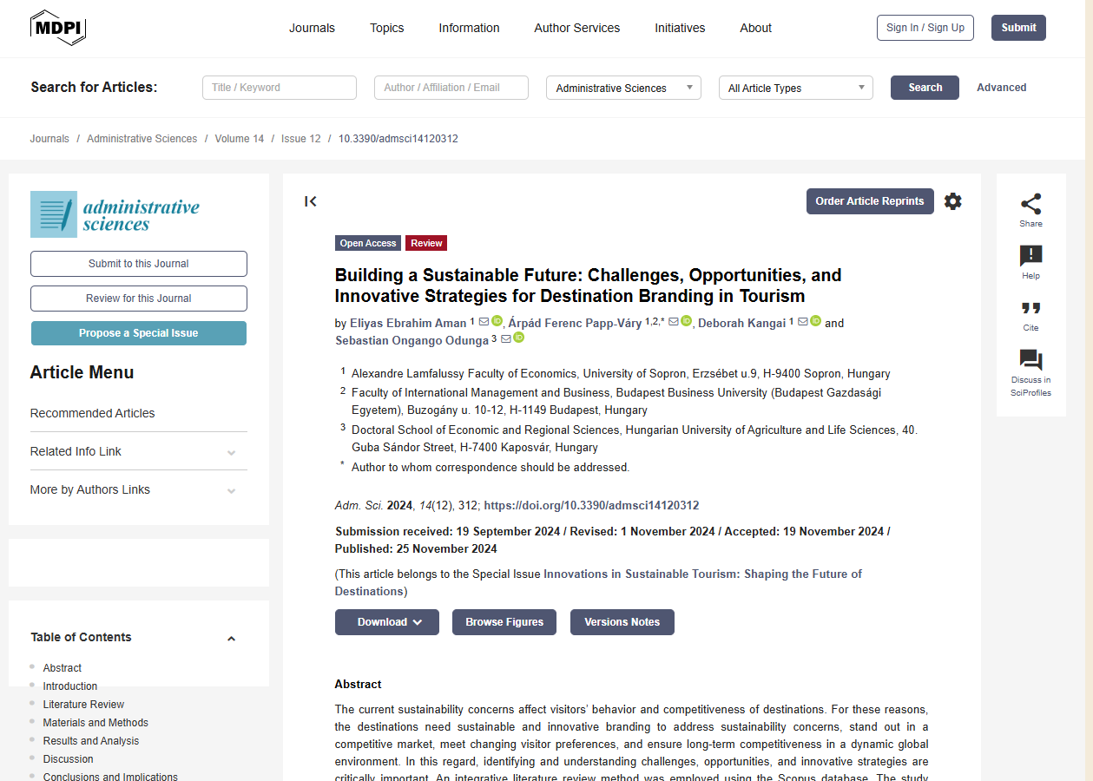

Bulchand-Gidumal et al. (2024
